IMX541 MIPI camera HW SOW

- The camera should have 2 PCBS a FPGA PCB and sensor PCB
- All the new components should be approved by KAYA
- Sensor PCB specification
  - The sensor should be IMX541
  - The sensor should operate on SLVS-EC mode
  - All the sensor voltages should be generated on sensor PCB
  - The connection between sensor PCB and FPGA PCB should be as in IRON FPGA board
  - Board size should be the same as IRON FPGA board

- FPGA PCB specification
  - Based on Polarfire MPF100T
  - An IRON FPGA board should be taken as a starting point
  - A Coaxpress interface should be replaced with MIPI CSI interface
  - The MIPI should use FPGA transceivers
  - MIPI pinout should be as below
  - MIPI connector should be I-PEX 20682-030E-02
  - The voltages towards the sensor board should be kept the same , If needed a change should be coordinated with KAYA
  - Input voltage is 5V +-20%
  - Board size should not changed unless coordinated with KAYA

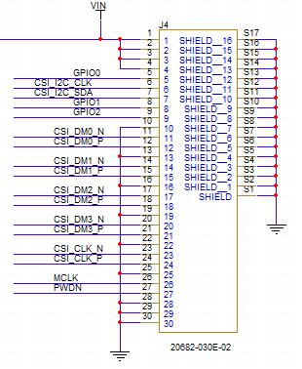
Figure 1: MIPI Pinout

MCLK and PWDN are 1.8V levels , I2C and GPIO are 3.3V levels

